|  |  |
| --- | --- |
| **Name** | Muhammad Asad |
| **Registration No.** | 2019EE383 |
| **Group** | G1 |

**Programming Fundamental**

**Lab no 10**

**Objective:**

In this Lab I simply print Star pattern.

**Task no 6**

* Use for loop to make the following shape:

* * * * * *

* * * * *

* * * *

* * *

* *

*

Note: use only one * with print.

**Code:**

#include <stdio.h>

int main(void){

const int Max=6;

int x=1;

int y=6;

for(x=1; x <= Max;x++)

{

for(y=6; y >= x; y--)

{

printf("*");

}

printf("\n");

}

return 0;

}

**Output:**



**Task no 7**

* Write a program using for loop which displays all the prime numbers from 50 to 100.

**Code:**

#include <stdio.h>

int main(void){

//Here I declare two objects and one variable.

int x=50;

int y;

int count=1;

//Here I use for loop.

for(x=51; x <= 100; x++)

{

bool the=true;

for(y=2; y <= x-1; y++)

{

if(x%y==0)

{

the=false;

break;

}

}

if(the==true)

{

printf("%d\n",x);

}

}

return 0;

}

**Output:**



**Task no 8**

* Make the following shape using for loop:



Challenge: use only one * with print.

**Code:**

#include <stdio.h>

int main(void){

int x;

int y;

int z;

int the=1;

printf("take no of rows ");

scanf("%d",&x);

the=x-1;

for(z = 1; z<= x; z++)

{

for(y = 1; y<= the; y++)

{

printf(" ");

}

the--;

for(y = 1; y <= 2 * z-1; y++)

{

printf("*");

}

printf("\n");

}

the=1;

for(z = 1; z<= x-1; z++)

{

for(y = 1; y<= the; y++)

{

printf(" ");

}

the++;

for(y = 1; y<= 2*(x-z) - 1; y++)

{

printf("*");

}

printf("\n");

}

return 0;

}

**Output:**

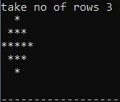

**Task no 9**

* Write a program to check whether a number is a palindrome or not.

**Code:**

#include <stdio.h>

int main(void){

/*Here I declares two objects and

one variable of integer data type.*/

int x;

int y;

int result;

printf("take a number ");

//Here I enter a number from user.

scanf("%d",&x);

y=x;

//Here I use while loop.

while(x>0){

result=(result*10)+x%10;

x=x/10;

}

if(result==y){

printf("num is palindrome ");

}

else

printf("num is not palindrome ");

return 0;

}

**Output:**

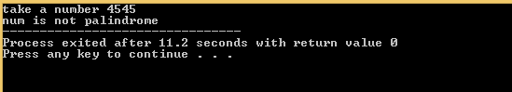

**Task no 10**

* Write a program which breaks down an integer in segments and display each digit of the integer in new line.`

**Code:**

#include <stdio.h>

int main(void){

//Here I declares two integer objects

int number;

int y;

printf("enter a number ");

scanf("%d",&number);

//Here I use while loop

while(number>0)

{

y=number%10;

printf("%d\n",y);

number=number/10;

}

}

**Output:**

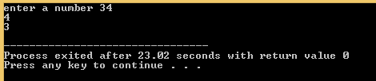

**Conclusion:**

In this lab, I learn the use of for loop,while loop and do while loops in C language.I sovle different problems in C language using loops.I solve previous lab problems in C language. I learn many things in this lab. It is very interesting and important lab. I feel better to do work on Dev C++ to perform these tasks.I also feel better to do work on netbeans. I hope that I will further learn in next lab.